PRACTICE 4
Determine the validity of the following three statements. Circle either True or False.
1. Group functions work across many rows to produce one result per group.
True/False
ANS→True
2. Group functions include nulls in calculations.
True/False
ANS→False
3. The WHERE clause restricts rows prior to inclusion in a group calculation.
True/False
ANS→True
The HR department needs the following reports:
4. Find the highest, lowest, sum, and average salary of all employees. Label the columns
Maximum, Minimum, Sum, and Average, respectively.
ANS→elect max(salary) “maximum”, min(salary) “minimum”, sum(salary) “sum”, avg(salary) “average” from employees;
- Modify the query in lab_04 to display the minimum, maximum, sum, and average salary for each jb type.

ANS→select job_id, max(salary) “maximum”, min(salary) “minimum”, sum(salary) “sum”, avg(nvl(salary,0)) “average” from employees group by job_id;

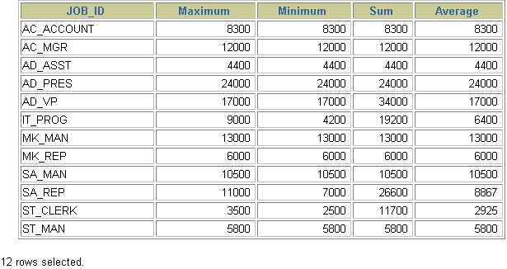
- Write a query to display the number of people with the same job.

ANS→select count(job_id), job_id from employees group by job_id;

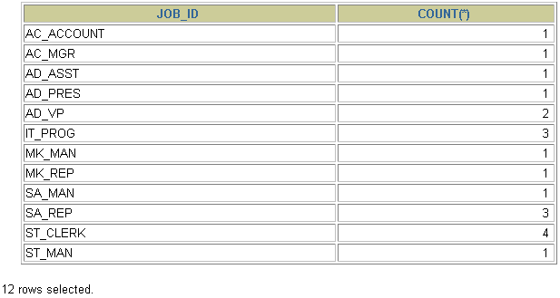
- Determine the number of managers without listing them. Label the column Number of Managers.
ANS→select count(distinct manager_id) “number of managers” from employees;
8.Find the difference between the highest and lowest salaries. Label the column DIFFERENCE.
ANS→select max(salary) - min(salary) difference from employees;

